**Exercise 8 – Small Multiples in Tableau**

Please use the screenshots ONLY as a reference. The written instructions have to be followed AS written.

PLEASE MAKE SURE YOU SUBMIT ALL THE SCREENSHOTS WITH TIMESTAMPS AT THE BOTTOM RIGHT (WINDOWS USERS) OR THE TOP RIGHT (MAC OSX USERS) OR ELSE YOU WILL AUTOMATICALLY QUALIFY FOR A DISCOUNT.

**About this exercise:**

**This exercise is divided into main 5 parts as listed below,**

**Part 1: Open tableau and import the data**

* Manly focused on the importing data and understanding what is provided in the data

**Part 2: Small multiples for Top 5 popular states of US**

* Plotting average yields of different commodities for the top 5 popular states of United States

**Part 3: Top Counties for state CA**

* In this part, we picked up one state California from the previous step and trying to fetch top 5 counties in terms of average yields produced

**Part 4: Small multiples for Top 5 Counties for state CA**

* Here, we are using the top 5 counties of California from the previous step and trying to understand the average produced yield pattern throughout years 1971 - 1975

**Part 5: Create a Story in Tableau using Rhetoric**

* Using the above visualization, creating a story to present it to the large audience so that they can understand the overall picture

**Part 1: Open tableau and import the data**

1. Download and open the latest version of Tableau Desktop
2. Click “Connect to Data”
3. Click Text
4. Navigate to the file on your machine (desktop) and open it

**Q. 1 Paste the screenshot of Data Source-------------------------**

**Part 2: Small multiples for Top 5 popular states of US**

1. Click “Go to Worksheet”
2. Make sure you have below field in Dimensions and Measures

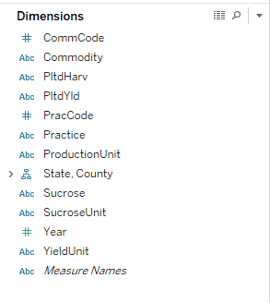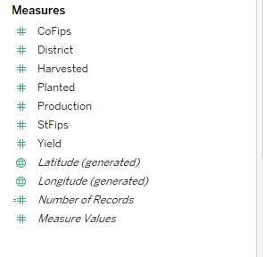

1. Drag Commodity and Yield to columns
   1. Use Average of Yield
2. Drag State and year to rows
3. Change Year from Continuous to Discrete.
4. Your column and rows should look like as below,

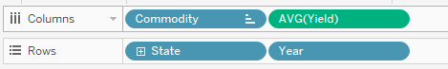

1. Drag State to filters pane
   1. Select CA, MI, NY, TX and VA States
2. After State now drag Commodity to filters pane
   1. Select Barley All, Corn for Grain, Wheat All and Wheat Winter All
3. Select visualization from Marks pane from Automatic to Shape
4. Change the title to ‘Small Multiples : Top Popular States : Student Name : 1976 – 1980’.
5. Rename worksheet accordingly
6. Select the fit to Entire View

**Q. 2 Paste the screenshot of the whole worksheet-------------------------**

**Part 3: Top Counties for state CA**

1. Create a new Worksheet
2. Drag State and County to columns
3. Drag Yield to rows
   1. Use Average of Yield
4. Your column and rows should look like as below,

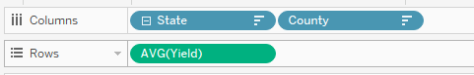

1. Drag State to filters pane
   1. Select CA State
2. Select the visualization from Marks pane from Automatic to Bar
3. Sort the visualization in the descending order of Avg(Yield) from below highlighted button from the Y-axis



Note: If the highlighted button is not visible hover on the Y-axis and you will get it.

1. Change the title to ‘Top Counties for CA : Student Name : 1976 – 1980’.
2. Rename worksheet accordingly
3. Select the fit to Standard View

**Q. 3 Paste the screenshot of the whole worksheet-------------------------**

**Q. 4 Write top 5 Counties of California from the visualization-------------------------**

**Part 4: Small multiples for Top 5 Counties for state CA**

1. Create a new Worksheet
2. Drag Commodity and Yield to columns
   1. Use Average of Yield
3. Drag County and Year to rows
4. Change Year from being Continuous to Discrete.
5. Your column and rows should look like as below,

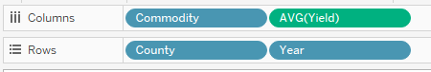

1. Drag State to filters pane
   1. Select CA State
2. Drag Commodity to filter pane
   1. Select Barley All, Sorghum For Grain, Wheat All and Wheat Winter All
3. Drag County to filter pane
   1. Select top 5 counties from Part 2
4. Select the visualization from Marks pane from Automatic to Shape
5. Change the title to ‘Small Multiples : Top 5 CA Counties : Student Name : 1976 - 1980’
6. Rename worksheet accordingly
7. Select the fit to Entire View

Q. 5 Paste the screenshot of the whole worksheet-------------------------

Q. 6 What insight you can infer from the visualization?----------------------

Q. 7 Which two commodities show a similar pattern change in average yield throughout the years for all counties?

**Part 5: Create a Story in Tableau using Rhetoric**

Tableau provides an option to display all your visualizations in the form of a story, in the above 4 parts we have created 3 different visualizations and now you need to displaythose viz in the form of a story. Implement one of the three rhetoric- ethical, logical or emotional using annotations and text boxes throughout the 4 sheets. Word the story elements such as title, subtitle, etc. accordingly.

* Your story should contain:
  + A story Title
  + All three worksheets
  + Each story point should have a suitable title
* Below links will help you in creating a story

[**http://onlinehelp.tableau.com/current/pro/online/mac/en-us/story_create.html**](http://onlinehelp.tableau.com/current/pro/online/mac/en-us/story_create.html)

Q. 8 Paste the screenshot of your story in Tableau. Make sure to include screenshots of all the data points. --------------------

Q. 9 Explain which rhetoric was used and how you used it. Why the Rhetoric you picked fits the visualization? --------------------

As a part of this exercise you need to submit following documents in eLearning:

* **Your Tableau file in file format twbx. If this file type is not submitted, there will be a discount.**
* **Word document with only the answers**